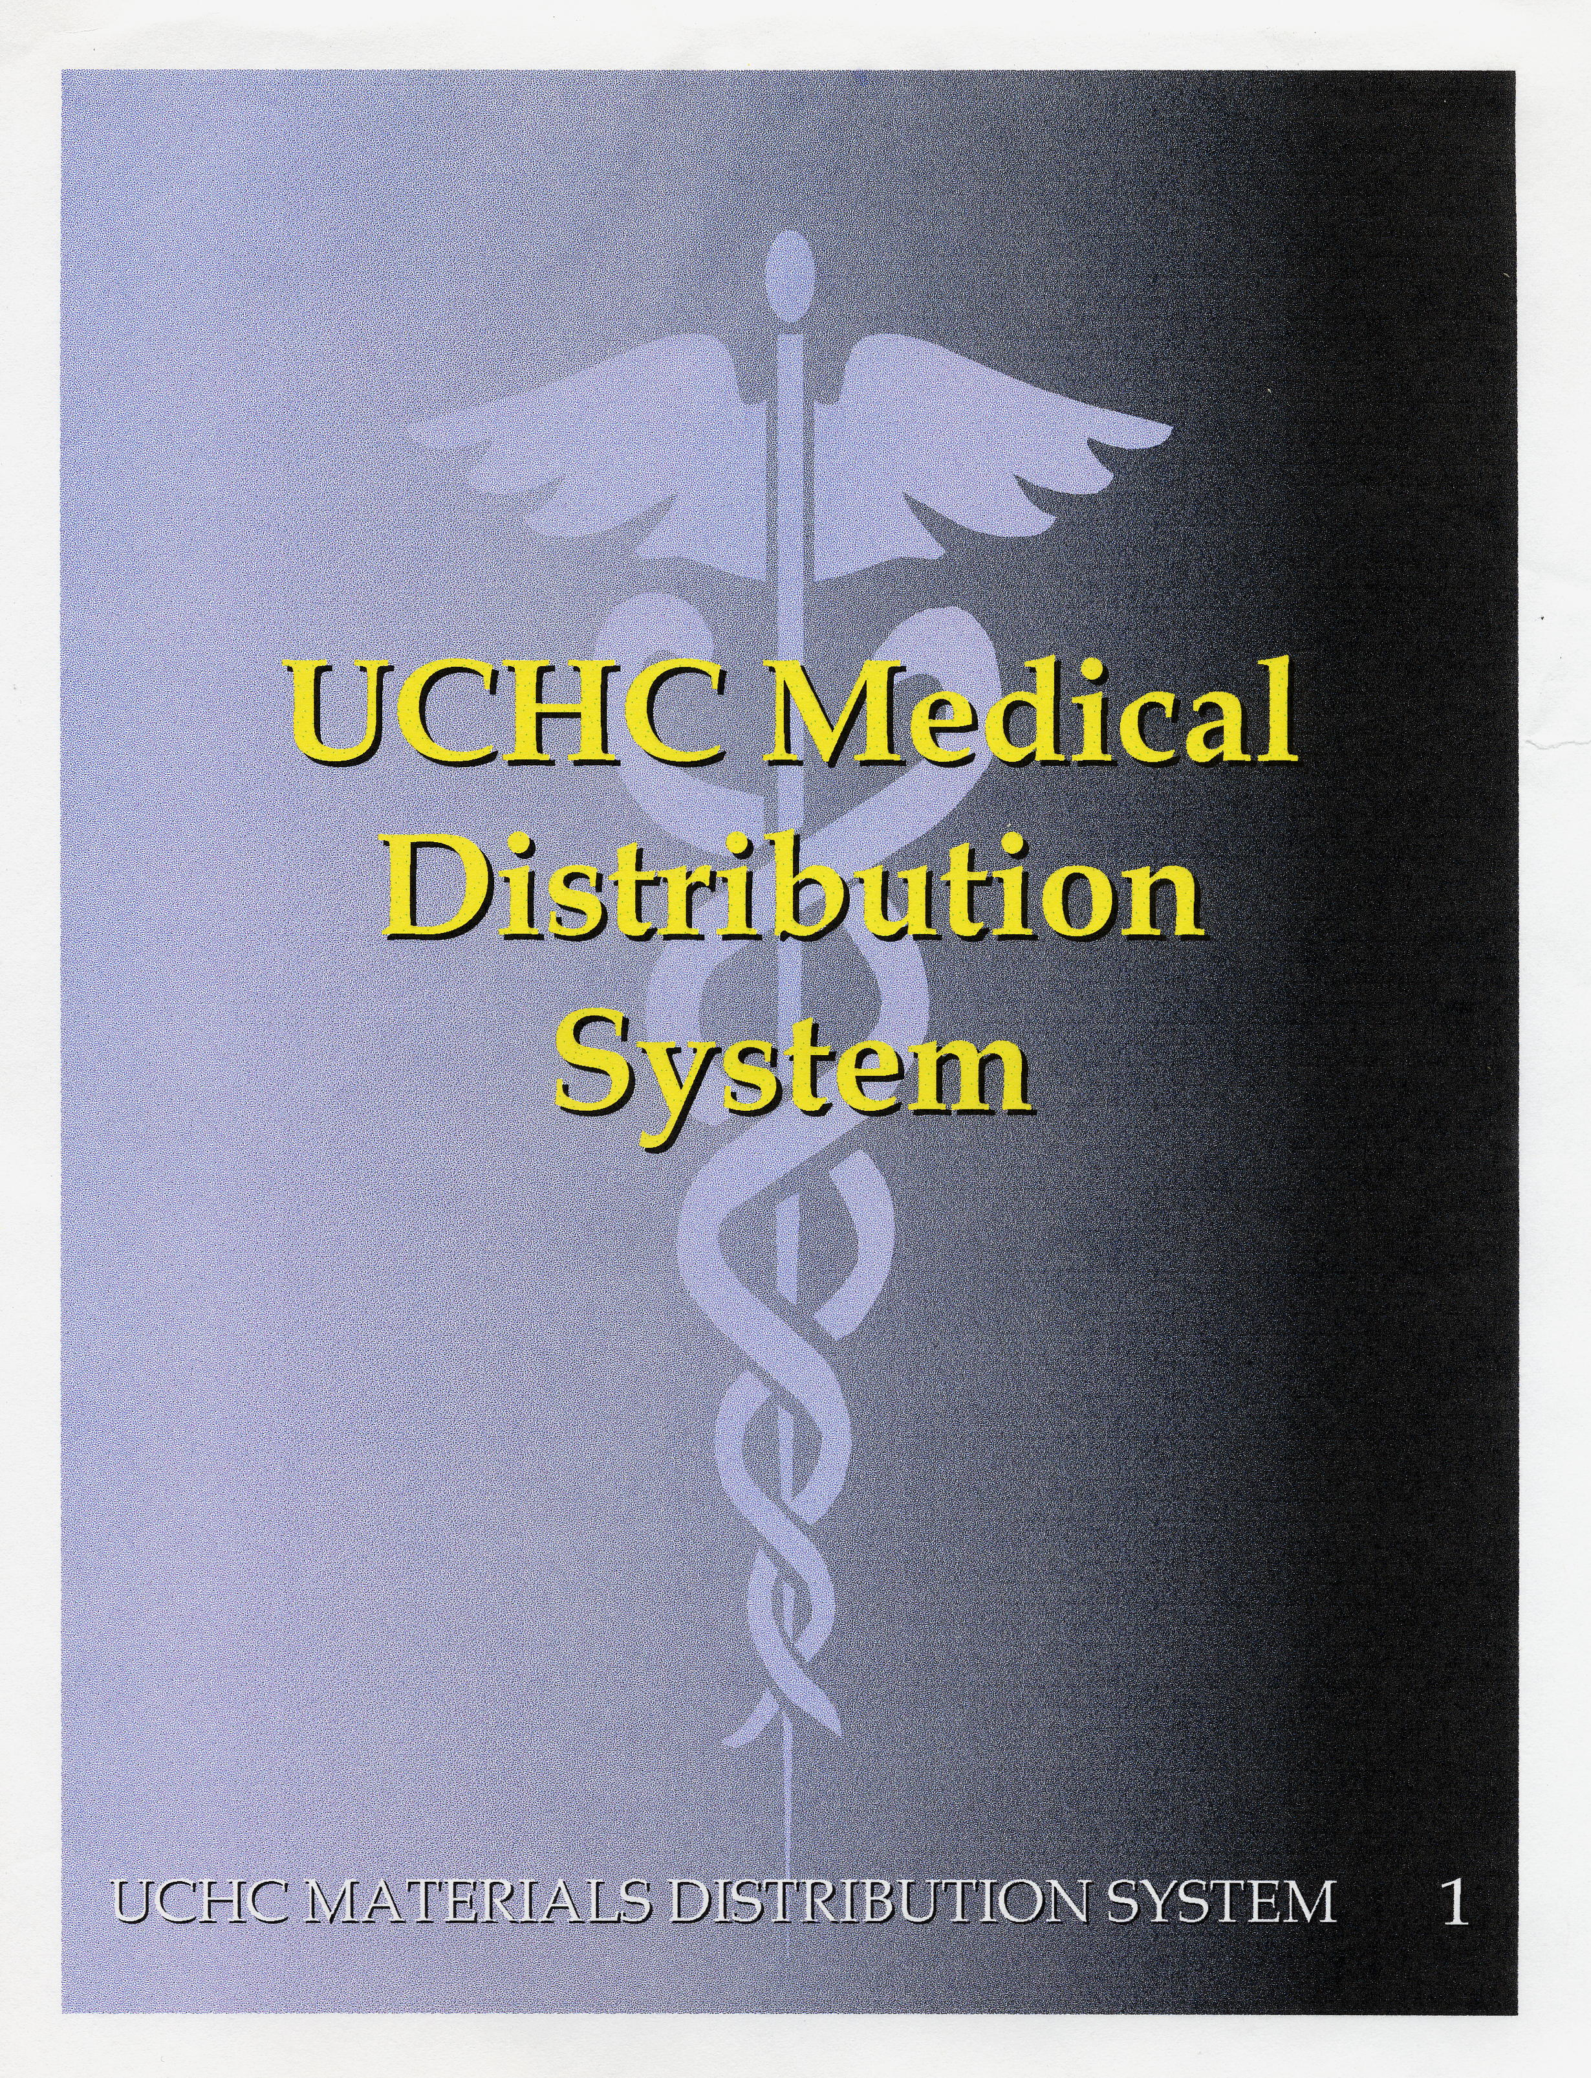

PAR and Supply Distribution System

OVERVIEW
- The PAR Program is focused on removing the Caregiver from the supply process and reducing costs by ensuring that supply activities were performed by the appropriate staff.
- Modify the skill mix and require Materials staff to pull supplies used routinely. This results in a reduction to the overall cost of completing the services.
- Provide supply distribution and replenishment services that met the needs of the customers by providing them with the correct types and quantities of supplies or other items, at the proper time and in the proper location. The PAR program developed meets the needs of the units, while being cost effective.
- Perform order placement, receiving, replenishment and over-all distribution functions with minimal labor requirements. Minimizing the time, effort and expense required.
- Set up all units so that staff can function easily on any Nursing and Clinical unit.
- Overall inventory reduction by developing the proper distribution methods, including the PAR program.
- An understanding by all parties of the importance of a strong and well maintained materials/supply chain program. A system that ensures the buy-in and support of everyone involved in that program.
- Build integrity and trust in the supply chain with Nursing and Physicians.

PAR Process Followed:
- Set-Up Team meetings with the Nurse Managers as needed.
- In the beginning of the PAR program, Materials Management monitored Nursing unit staff as they completed the supply process for their units. Now that we have an excellent understanding of the clinical process; we discuss with the appropriate nursing staff the current supply process for their units. We then analyze the general flow of supplies on the units to the patient rooms.
- Review distribution practices.
- Review the stocking locations, inventory, replenishment practices and schedules.
- Identified stock and non-stock supplies ordered for each unit.

PAR Administration:
- See attached exhibit Models, 1-3
- See Related Materials Management Forms
- Weekly action group meeting(s) established to continue the work and ensuring good supply chain/materials management practices are maintained.

Supply Redesign:
- Based on what is found during the review process, the units are redesigned accordingly. (See before & after pictures provided)
- Metro Racking and tote system replace wood shelving, cubby spaces, hidden inventory (stash), unofficial stores, supply closets, rooms, etc.
- In almost all cases, supplies are moved closer to the patient rooms where used.
- Unit supply rooms were all removed during our initial implementation, except in the OR and NICU. (Materials Management will be reviewing a PAR system for the multiple units in Neonatal).
- The entire distribution system is redesigned to accommodate the PAR program. Supplies are picked and packed for specific unit locations, streamlining the entire replenishment process.
- All supply areas are set up by category, taking the guess work out for the Caregiver, especially for Staff as they move from unit to unit. Convenient and Time efficient.

RELATED MATERIALS MANAGEMENT FORMS
- PAR ADJUSTMENTS
All adjustments require signature of the Materials and Nursing Manager
- PAR PROJECT REQUESTS, INCLUDES Q-SIGHT (As of March 2006)
Getting Started
Project Check List
- PRODUCT DEFERRAL
Requires appropriate signature
- PRODUCT EVALUATION
- PRODUCT REQUESTS

U.S. STANDARD PAR FORMULA
(Periodic Automatic Replenishment)

1. PAR = *Average Usage between fills x 2
* Average Usage between fills = the weekly Usage divided by the Frequency
of replenishment. (24/5 = 4.8) x 2 = 9.6 or PAR value

2. OR PAR FORMULA

OR PAR: Usage/52 x Weeks (Re-Order Point) x 2 = PAR
(or 1.5)
"A" Critical Items

A5 = Annual Usage/52 x4 (Includes 5 day Safety Stock Factor)
EXAMPLE:

Annual Usage:
200 / 52 = 3.8

3.8 x 4 = 15.2 or Re-Order Point

15.2 x 2 = 30.4 or PAR

Min - Max
A4 = Annual Usage/52 x3.8 (Includes 4 day Safety Stock Factor)
A3 = Annual Usage/52 x3.6 (Includes 3 day Safety Stock Factor)
A2 = Annual Usage/52 x3.4 (Includes 2 day Safety Stock Factor)
A1 = Annual Usage/52 x3.2 (Includes 1 day Safety Stock Factor)

"B" Less Critical/Frequently Used Supply

B5 = Annual Usage/52 x3 (Includes 5 day Safety Stock Factor)
B4 = Annual Usage/52 x2.8 (Includes 4 day Safety Stock Factor)
B3 = Annual Usage/52 x2.6 (Includes 3 day Safety Stock Factor)
B2 = Annual Usage/52 x2.4 (Includes 2 day Safety Stock Factor)
B1 = Annual Usage/52 x2.2 (Includes 1 day Safety Stock Factor)

"C" Routine/Readily Available Supply Items

C5 = Annual Usage/52 x2 (Includes 5 day Safety Stock Factor)
C4 = Annual Usage/52 x1.8 (Includes 4 day Safety Stock Factor)
C3 = Annual Usage/52 x1.6 (Includes 3 day Safety Stock Factor)
C2 = Annual Usage/52 x1.4 (Includes 2 day Safety Stock Factor)
C1 = Annual Usage/52 x1.2 (Includes 1 day Safety Stock Factor)

Three different models were developed for the distribution and replenishment processes for routine items. (See Flow Charts attached)
• Nursing Units
• Clinics
• Ancillary Clinical service areas and ED

Nursing Unit Model

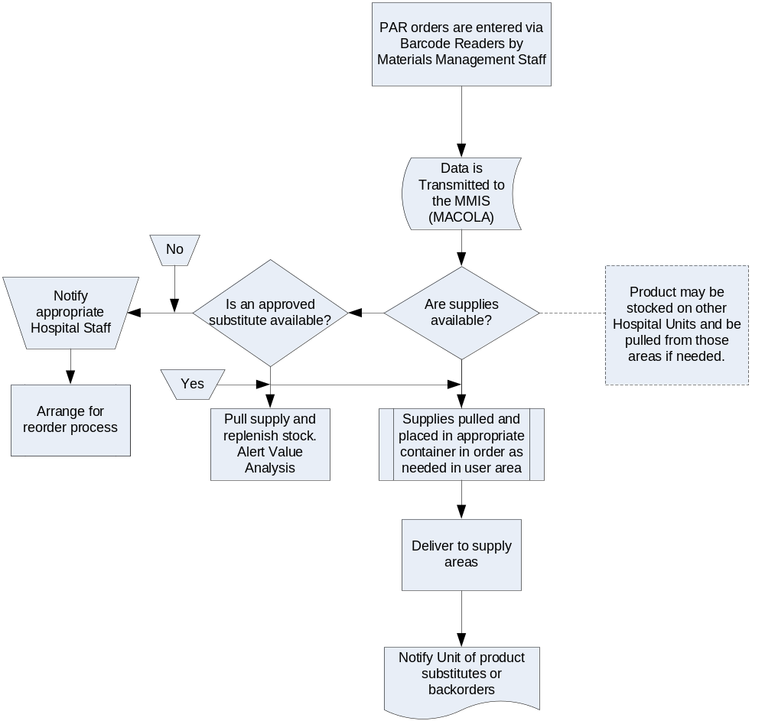

Clinical Model

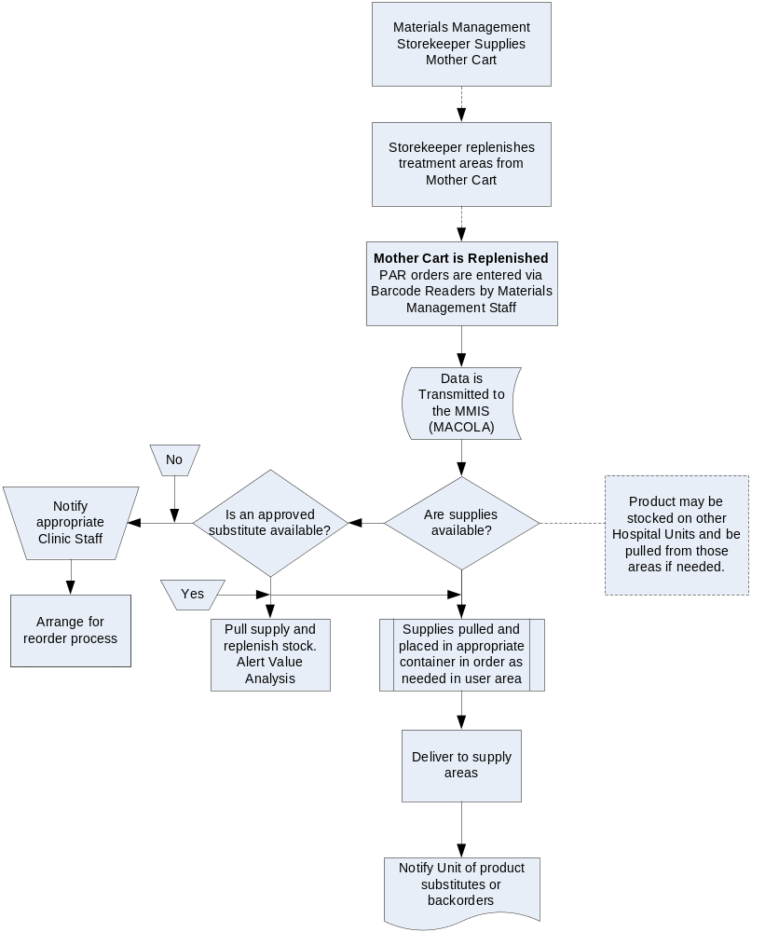

ED & Ancillary Units

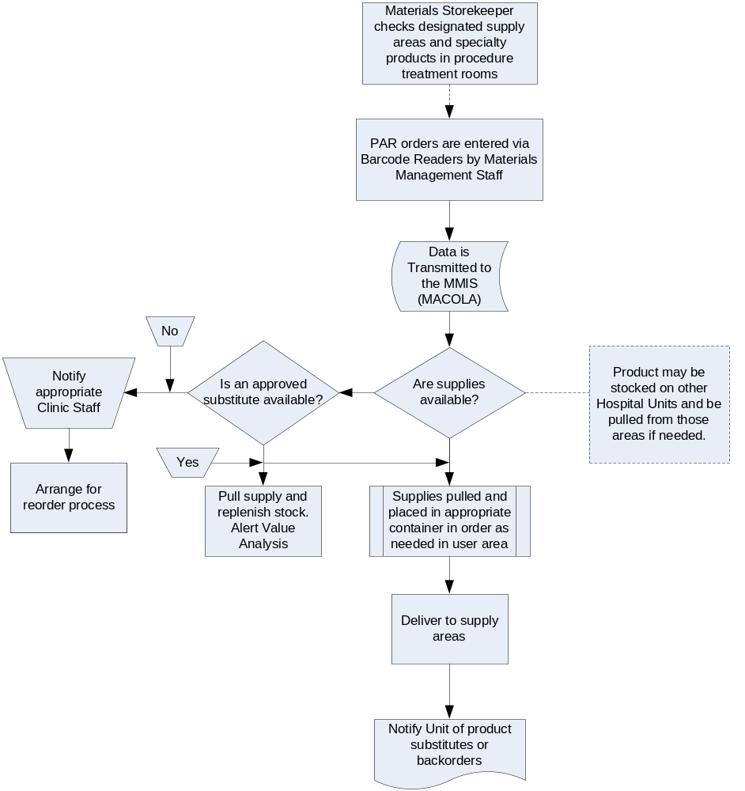

Before and After Photos:

ICU BEFORE

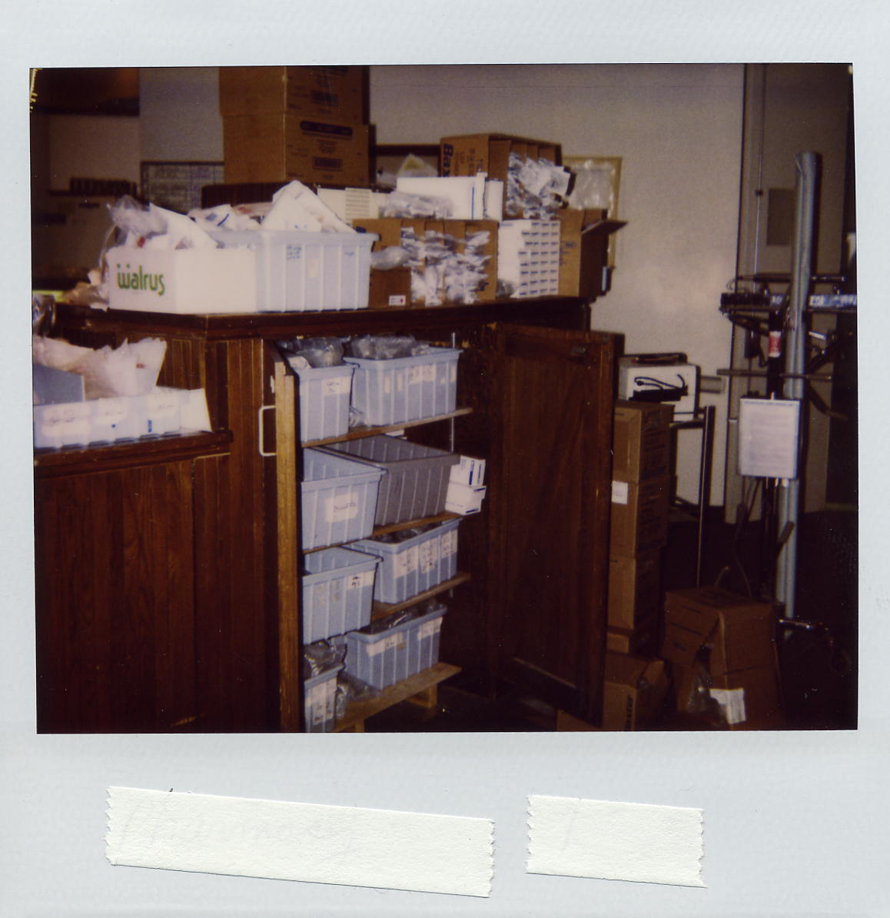
ICU BEFORE PAR IMPLEMENTATION

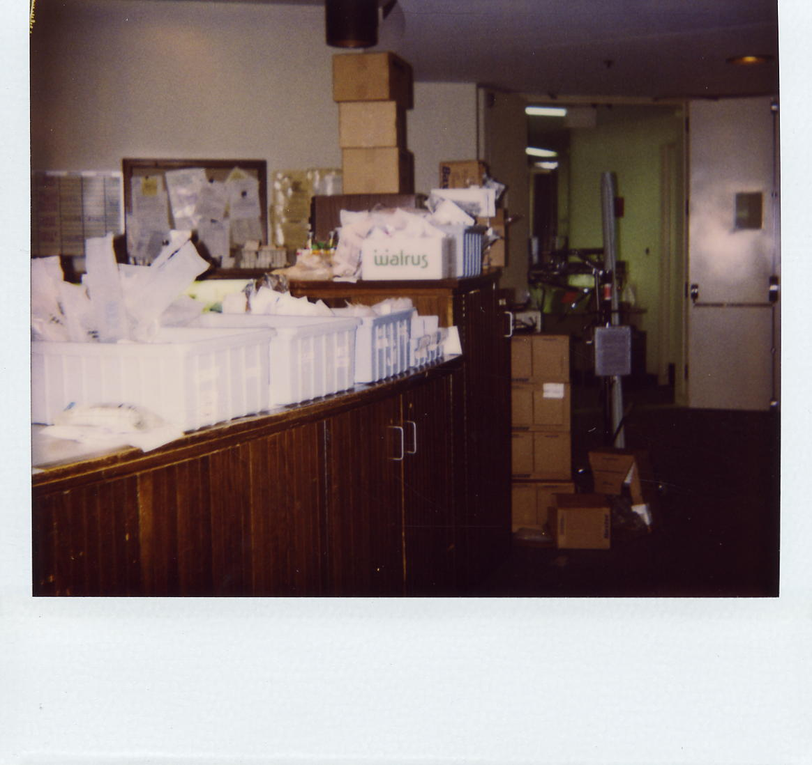
ICU BEFORE PAR IMPLEMENTATION

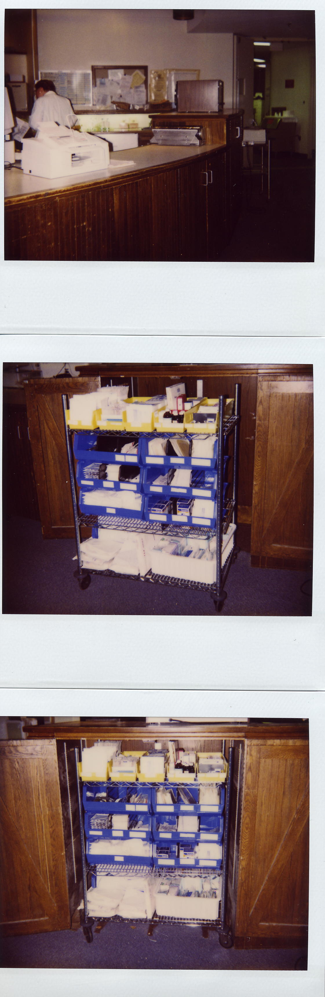
ICU AFTER IMPLEMENTATION
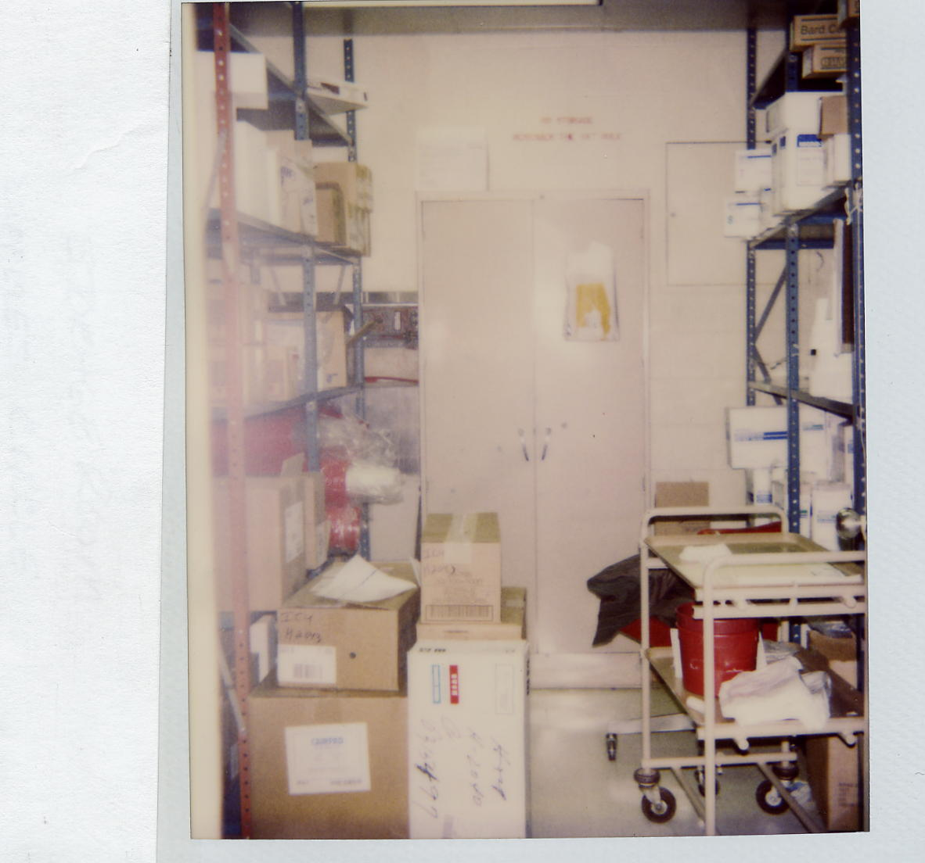

All Unit stockrooms were removed during Phase II

This is one of the smaller rooms in the ICU

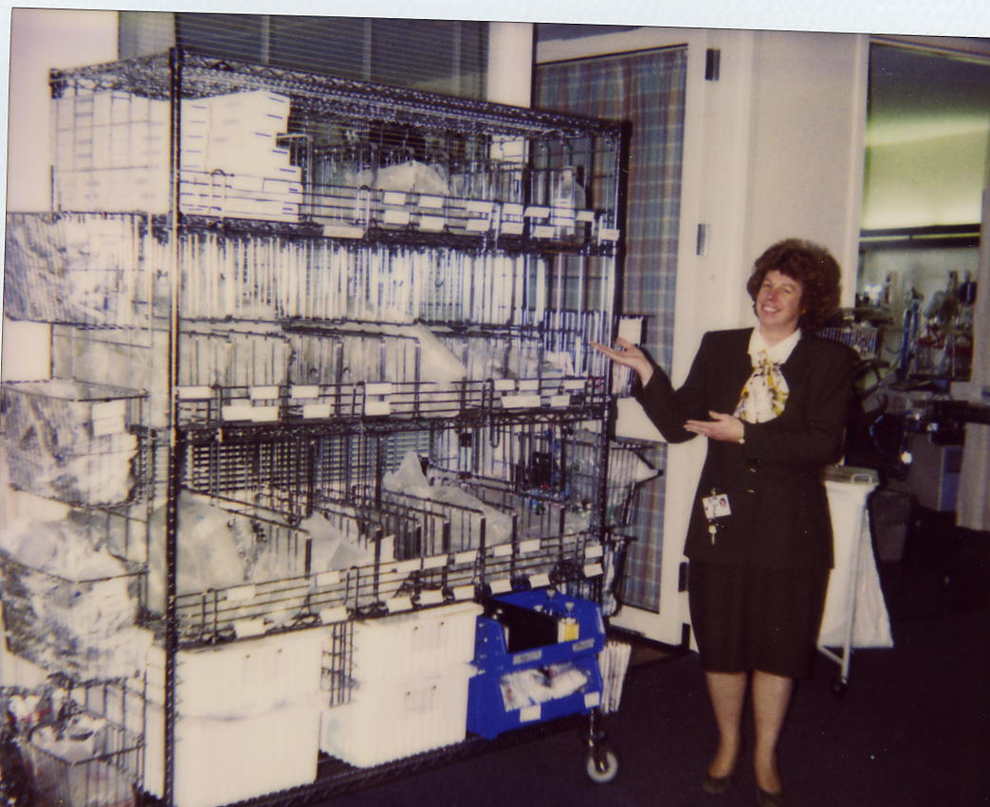

A Happy Nurse Manager

