Processing Asset Management Requests Using Electronic Forms Workflow
This process will outline how to use Electronic Forms Workflow (EFW) to manage unit asset movement and disposition previously documented using Logistics Management (LM) and Inventory Control (IC) forms. This process is currently set up to replace the LM-1, LM-2, IC-4, IC-5 and IC-6 forms. To facilitate easier use of this procedure it has been divided into sections relating to each previous form so that users will be able to navigate to pertinent points depending on what they wish to accomplish.
All processes described herein shall be ultimately governed by the UConn Health Inventory Control Manual as well as the State of Connecticut Property Control Manual and any applicable State and Federal statutes regarding Capital or Controllable assets. The use of these forms shall not be limited strictly to Capital and Controllable assets on record but any tangible or intangible property used by UConn Health which is not normally regarded as consumable in nature.
Above is the legal disclaimer that all items should be put on forms regardless of whether they are capital items or not. This follows our normal process using the paper forms where items without tags can be entered as well as tagged items that may not be capital, such as clinical or controllable items. Questions can always be directed to us, as clarity is essential in completing these forms.
The process shall be administered by the Office of Logistics Management (OLM). You can contact them for further information at assets@uchc.edu, mail code 2012, or phone (860)679-8749. Links to additional information and resources can be found at http://opa.uchc.edu/index.htm.

Contents:
Introduction: Creating a Form Page 3
(Brief description of the Profile section of the forms which can be preset for ease of use)

Old Form # Description
LM-1 Requesting/Reporting a Move Page 5
(Assets to be moved between two rooms within the same department)

LM-2 Reporting Surplus Page 7
(Assets no longer needed by the department. Removal Request)

IC-4 Receipt of Transfer Page 8
(Assets received from another Agency, Institution, or Company)

IC-5 Loan Request Page 11
(Assets being loaned to another UCH Department, State or Federal Agency, Institution, Company or Individual)

Due to the myriad number of scenarios covered by the original IC-6 form; in EFW it has been broken into three distinct sections. See IC-6, IC-6A and IC-6B below.

IC-6 Record of Property Disposition (Transfer, Other) Page 13
(This form records permanent transfer to another UCH Department, State or Federal Agency, Institution or Company; or other dispositions which are not listed as a distinct category, ex. Missing assets, items returned under warranty, loss due to theft/vandalism or environmental damage)
IC-6A Record of Property Disposition (Trade-In) Page 14
(This form has a spot for the credited PO to be entered. This is for items which are returned to a vendor/supplier for credit against a replacement piece of equipment. This MUST be approved by the Purchasing Department.)
IC-6B Record of Property Disposition (Sell) Page 15
(This form should only be filled out by Surplus Store or Purchasing staff when an item has specifically been put up for direct sale following all necessary state and federal guidelines)
IC-6C Record of Property Disposition (Cannibalize) Page 16
(This form is to show when equipment has been TOTALLY destroyed to repair or build another item. Please contact OLM prior to entering to make sure your item qualifies.)
Legal Notifications: Preparing Equipment for Movement, Transfer or Disposal Page 17
Adding Assets to Your Form Page 18
Looking Up Current Asset Information Page 20
Workflow: Request Routing and Searching for Requests Page 22

Introduction: Creating a Form
http://nso-srv-macola.uchc.net/efw_training/

After clicking the link above you will be brought to this screen to create a new form. This is the default screen for the system.

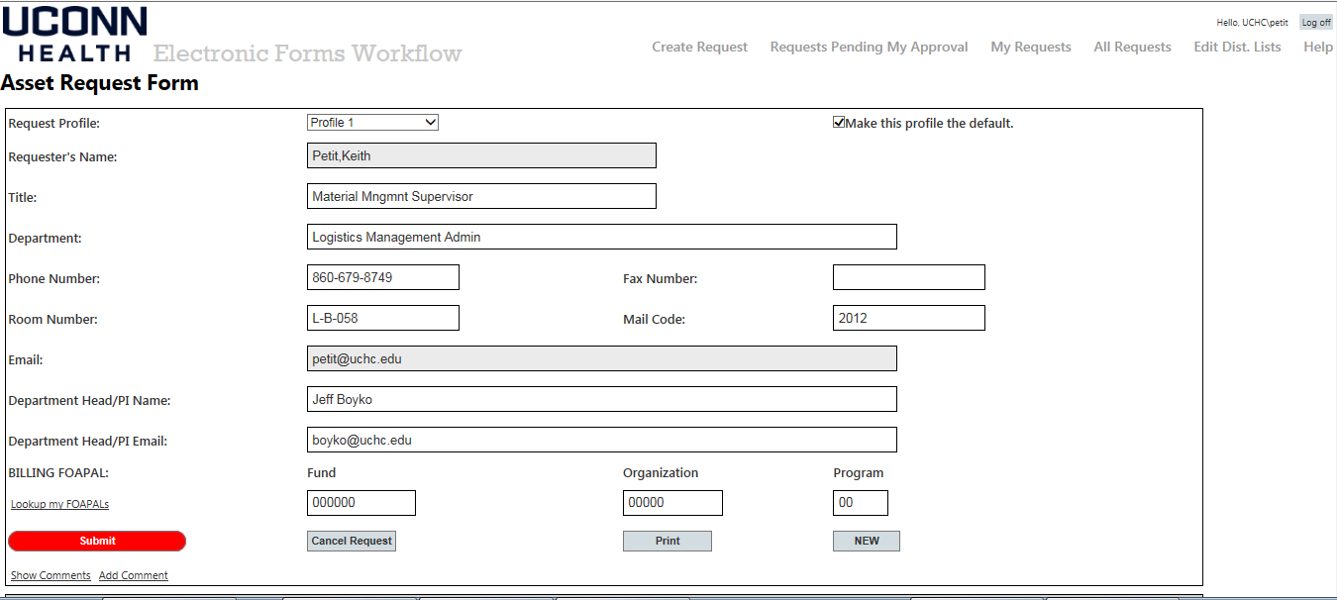

Your information from Active Directory will prepopulate into the form. You can also create other basic profiles by clicking the dropdown on the Request Profile field. A separate Profile Name Field will appear so you can name your new profile.

Once you have submitted a request using a new profile name it will be saved for future use. This will allow you to save certain routing and accounting strings (FOAPLs) so that requests for different Principle Investigators (PIs), projects or grants are prepopulated with the correct information.

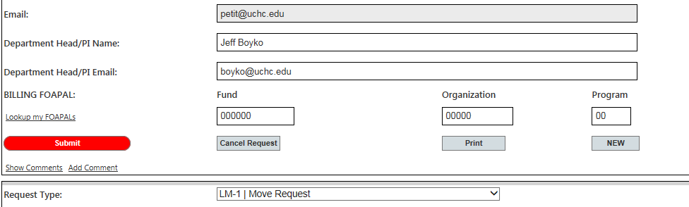
In this section of the form are several action buttons and links. On the left above the Submit button is a link to look up a FOAPL combination. This provides a dropdown that is prepopulated with all the FOAPLs listed to both the requestor and the person entered in the Department Head/PI fields in Banner. If the FOAPL you need is not listed you will need to submit an LM-3 to have signature authorization assigned to the PI or department head.

Once you have selected the proper FOAPL it will populated the FOAPL fields on the right. At this point you can enter any additional comments you want to go with the form. Under the submit button are links to show and add comments to the form. Clicking the “Add Comment” link will show a popup box for you to add any pertinent information. Individual comments are restricted to 1000 characters but multiple comments can be added at any stage. Comments are required when you cancel a request and are automatically entered by the system when a request is reinitiated.

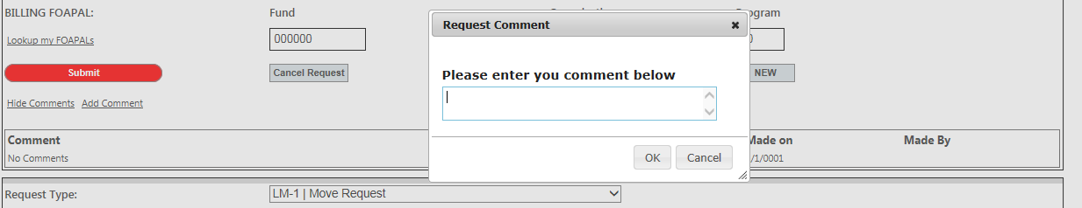

The Submit button should be used after you have completed the entire form and are ready to send it to the approver. If this button is selected prior to finishing the form, any incorrect fields will be displayed in red and have a red asterisk at the far right of the field. These problems must be fixed before the form can be submitted. Click the Submit button again to resubmit.

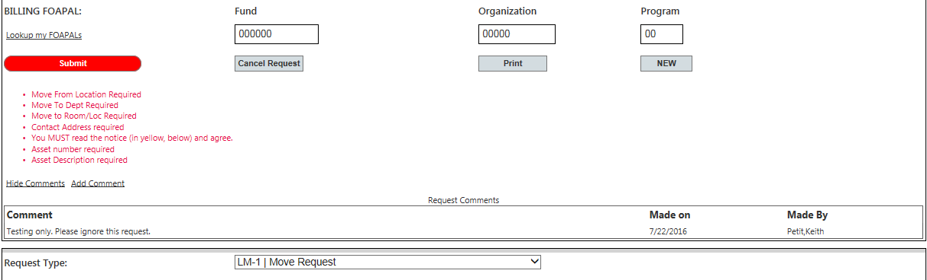

There are also buttons to cancel a request, print the form for your records or reset the form so a new request can be submitted. Forms do no need to be printed every time because the historical data will be available using the reporting and search functions of the EFW program.

Fields below this point will vary determined by which form type you select. Since they will vary by form their occurrence and use will be described more fully under each form title in future sections of this manual.

LM-1: Requesting/Reporting a Move
LM-1 Purpose: This form is to be used in three distinct instances; (a) to inform Logistics Management when a moves a piece of equipment from one room to another; (b) when assistance from the contracted moving crew is required to take items from one location to another within a department; (c) or a unit is requesting that equipment be put into temporary storage (both on-site and off-site storage must be reported).
In the second section of the EFW request is a dropdown where you select the type of action you wish to perform. To keep continuity with the old processes we aligned request types with their old LM and IC form numbers. This will allow users familiar with the previous system to have a better idea of which form type to start with. The fields on the form will vary depending on which type of action is selected in the dropdown. Here we will describe the form as it appears when the LM-1 selection is made.

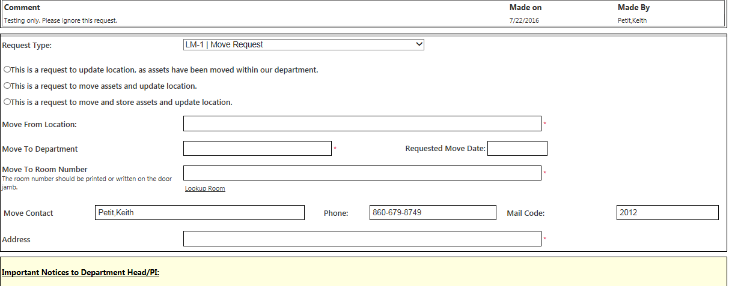

Immediately below the dropdown are three options:
- Request to update location, as assets have been moved within our department.
  - This is used when the items have already been moved but you want to inform OLM of the new location, room number, within your department (transfers between departments require a different form). Your FOAPL should not be charged for this type of transaction but it is still necessary to complete the form.
- Request to move and update location.
  - This option is used when you need to schedule the movers to come and physically relocate assets within your department. Your FOAPL may be charged depending on the time and number of movers required to affect your move.
- Request to move and store assets and update location.
  - Use this selection when you wish to put the items into temporary storage. Your FOAPL will be charged for the move as well as any storage charges incurred. Temporary storage is restricted to one year. Storage longer than a year will require additional permissions and forms. Contact the moving and storage scheduler for more information (assets@uchc.edu).

The ‘Move From Location’ field is not limited to just the room number. You should enter the FAMIS room number for uniformity but you can also enter additional information for ease of use. Ex. “FB053 items outside in hallway”. This allows the movers to use the FAMIS code to get to the general area and any extra information to pinpoint what items to take.

Enter the Requesting Department name and the Requested Move Date. The scheduler will try to take the request date into account when scheduling your move, but it ultimately depends on the size of the move and the availability of the moving services. Once the scheduler has approved your request the Scheduled Move Date field will be filled in. After the move is completed the Actual Move Date field will be filled.

Enter the Move to Room Number exactly as listed in FAMIS. These numbers are usually found on the doorjamb of the room. In some cases they may have been painted over or the tag removed. Some have been hand written after being painted over.

A link has been provided to lookup the room number. This allows you to select the building, floor and room from a dropdown of available numbers in FAMIS. This list may not be all inclusive. If the room that you think should be listed is not, or if you have problems locating a room number contact the assets team, assets@uchc.edu, and someone will give you the official room number and make arrangements to relabel it (FAMIS is controlled by Campus Planning and changes are ultimately done at their discretion).

The last part of this section contains fields for you to enter the destination contact information. Put the name of the contact person at the destination location, their phone and email address. This will allow us to contact them when scheduling a move so there is someone to receive it at its destination. All locations, even offsite storage addresses, would need to be typed in.

This concludes the parts of the form specifically addressing equipment moves, LM-1. To complete the rest of the form go to the section on Legal Notifications (page 17).

LM-2: Reporting Surplus
LM-2 Purpose: This form is to be used to declare surplus items in your unit. These will be removed and evaluated for either reuse by other departments, public sale or disposal. Units are not charged for removing surplus because the costs are offset by the benefit of reusing items elsewhere or public sale.
In the second section of the EFW request is a dropdown where you select the type of action you wish to perform. To keep continuity with the old processes we aligned request types with their old LM and IC form numbers. This will allow users familiar with the previous system to have a better idea of which form type to start with. The fields on the form will vary depending on which type of action is selected in the dropdown. Here we will describe the form as it appears when the LM-2 selection is made.

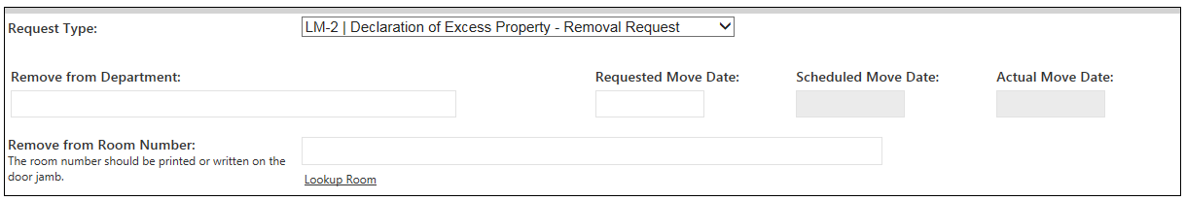

Because removal to surplus is a pretty basic function, the only fields required are:

Remove from Department –
Enter a brief description of where the items are being removed from. Ex. “PACU the first three bays by TG421”

Requested Move Date –
Enter the date the items are available for pick up. The scheduler will try to take the request date into account when scheduling your removal, but it ultimately depends on the amount of equipment being removed and the availability of the moving services. Once the scheduler has approved your request the Scheduled Move Date field will be filled in. After the items have been picked up the Actual Move Date field will be filled.

Remove From Room Number –
Enter the specific room number where the items are located. These numbers are usually found on the doorjamb of the room. In some cases they may have been painted over or the tag removed. Some have been hand written after being painted over.
A link has been provided to lookup the room number. This allows you to select the building, floor and room from a dropdown of available numbers in FAMIS. This list may not be all inclusive. If the room that you think should be listed is not, or if you have problems locating a room number contact the assets team, assets@uchc.edu, and someone will give you the official room number and arrange to relabel it (FAMIS is controlled by Campus Planning and changes are ultimately done at their discretion).

This concludes the parts of the form specifically addressing surplus removals, LM-2. To complete the rest of the form go to the section on Legal Notifications (page 17).

IC-3/4: Receipt of Transfer
IC-3/4 Purpose: This form is to be used when receiving equipment form an outside source. Examples include; when a new Principle Investigator arrives with equipment from another institution, when a state or federal agency loans or gives us equipment, and when a private company or individual loans or gives us equipment. This form also covers items “donated” to UConn Health.
In the second section of the EFW request is a dropdown where you select the type of action you wish to perform. To keep continuity with the old processes we aligned request types with their old LM and IC form numbers. This will allow users familiar with the previous system to have a better idea of which form type to start with. The fields on the form will vary depending on which type of action is selected in the dropdown. Here we will describe the form as it appears when the IC-4 selection is made.

The IC-3/4 is different from the other forms in a very distinct manner. It is set up to only allow a single asset entry. It was set up this way for two reasons. First, because the item being described does not yet have an asset tag number. So more information is required up front for us to determine what type of tag it should have and how it should be entered in the system. Second, when the system is eventually upgraded to directly upload to the Financial Reporting System it will need to be very specific and have a lot more information to fulfil the needs of activating a new asset tag.

In an effort to make the system’s first release more efficient for units it is possible to quickly send us a larger set of equipment requests by attaching an excel sheet with the information for multiple pieces of equipment.

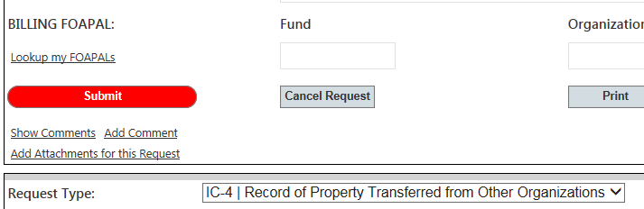
In the comments section please detail how many items are being added so that we know to look for an Excel sheet and so there is a written statement tying the Excel file to the request for audit purposes.

You should also add any attachments for items which are being loaned or given to UConn Health under specific terms, or are accompanied by a contract or loan document. Click the “Add Attachments for this Request” link. Multiple documents can be uploaded and removed if loaded in error.

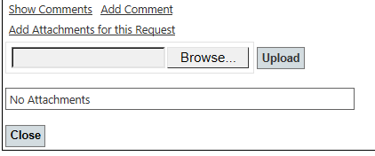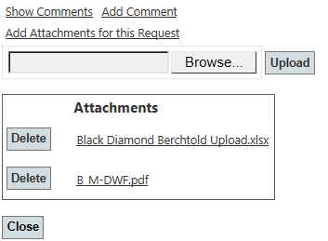

Below the comment and attachments section is where you can enter the conditions of the transfer; ex. one year loan, permanent grant relocation. Enter the transferring organization which could be a school, research institute, Federal or State Agency to name a few. Enter the contact information of someone at the transferring organization. If additional information is required we may need to reach out to them.

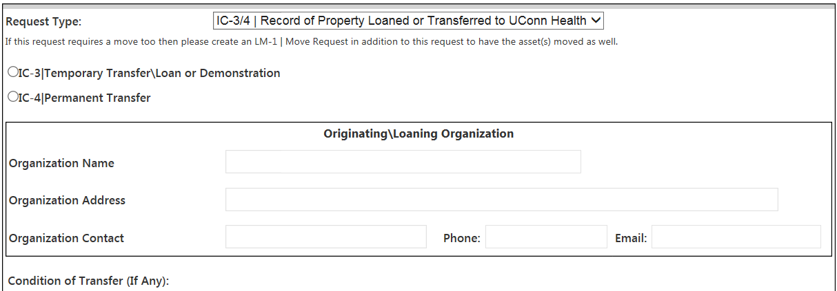
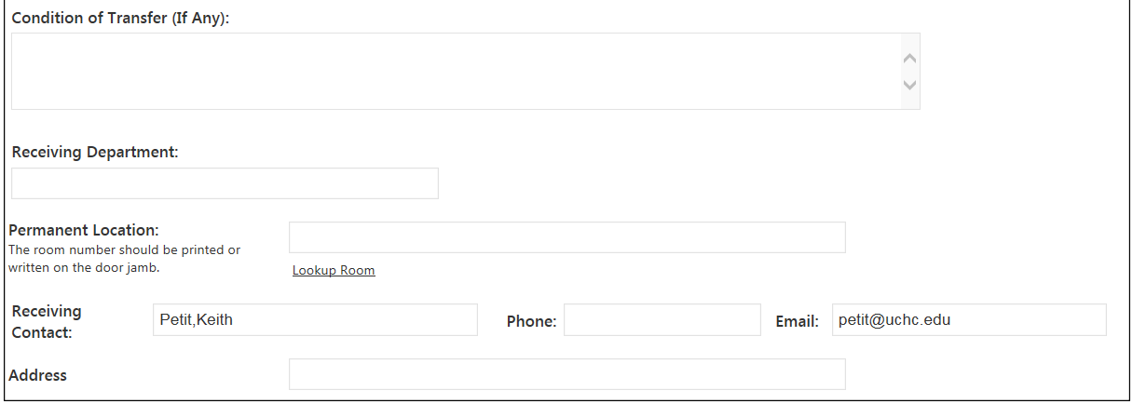

Finally, enter the information related to the piece of equipment being transferred. As discussed previously, if there are multiple pieces they can be entered on an Excel sheet containing columns matching all the fields listed in this section. Please be as thorough as possible because this information will be used to identify the equipment for many inventory cycles going forward.

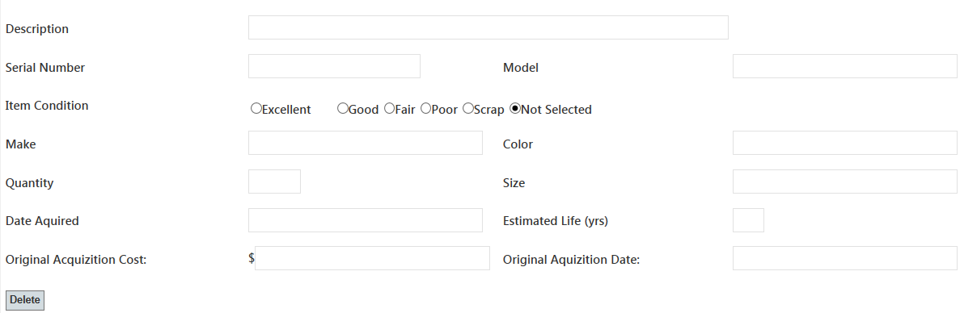

- Description:
  - This is up to 60 characters to describe the object. Often the model or make will be in this but if you are pressed for space please remember that the make and model information are also recorded elsewhere. OLM may adjust it somewhat to match up with other similar items.
  - Ex. “Computer, Laptop” to begin the field then other items like “E350 15in 1TB HDD 8GB RAM”
- Serial Number:
  - Enter the Serial Number found on the item. If the item has a LOT number instead you can enter that. Please specify so we know by entering “LOT 27645”
- Model:
  - Enter the model name or number.
- Item Condition:
  - Enter your estimate of the item condition.
    - Excellent – New or Like New
    - Good – Some wear and tear but has several years of life remaining.
    - Fair – Still working but its best years are obviously behind it.
    - Poor – Very close to the end of its useful life. Could use repairs.
    - Scrap – Broken or barely working and not worth repairing. Past its useful life.
- Make:
  - Enter the manufacturer or maker of the equipment.
- Color:
  - Colors should be one word. If more description is needed say light or dark.
    - Good: Blue, Grey, Silver, Dark Gray
    - Bad: Burnt Sienna, Midnight Blue, Periwinkle, Forest Green
- Quantity:
  - Should usually be one because we want serial numbers tied back on a one for one basis.
  - Can be >1 if it is a lot only or does not have serial numbers.
  - If submitting via Excel, use 1 per line so we can more efficiently assign asset tags.
- Size:
  - Enter dimensions if available.
  - Length x Width x Height is standard format. (42in.x28in.x16in.)
- Date Acquired:
  - This is the date the item will be received into UConn Health custody.
- Estimated Life:
  - Please estimate the remaining life on the item. This will assist in assigning any depreciation if necessary.
- Original Acquisition Cost:
  - Enter the original cost of the item.
- Original Acquisition Date:
  - Enter the original purchase date of the item, or when it was made.
  - Documented for an overall age in contrast to how long it has been at UConn Health.

This concludes the parts of the form specifically addressing Receipt of Transfers, IC-4. To complete the rest of the form go to the section on Legal Notifications (page 17).

IC-5: Loan Form
IC-5 Purpose: This form is to be used when equipment is loaned to another UConn Health department, to an employee or contractor conducting State business, or to another institution. Items are required to have an estimated return date. These forms must be renewed annually and all items listed on the forms will still be subject to annual inventory by the Office of Logistics Management. The items will be inventoried in conjunction with the loaning unit’s annual inventory by OLM.
In the second section of the EFW request is a dropdown where you select the type of action you wish to perform. To keep continuity with the old processes we aligned request types with their old LM and IC form numbers. This will allow users familiar with the previous system to have a better idea of which form type to start with. The fields on the form will vary depending on which type of action is selected in the dropdown. Here we will describe the form as it appears when the IC-5 selection is made.

The IC-5 is a loan form, which is a temporary document. Items listed on loan forms must still be accounted for in the UConn Health annual inventory. This physical inventory will be conducted in conjunction with the loaning unit’s annual inventory by OLM. The equipment will still be the responsibility of the loaning unit. The form must be renewed annually. This allows the loaning unit to assess the current condition of the item and whether the purpose of the loan still exists. The system will provide a report to OLM showing all loans which are at their 11th month so that they can be examined by the loaning unit.

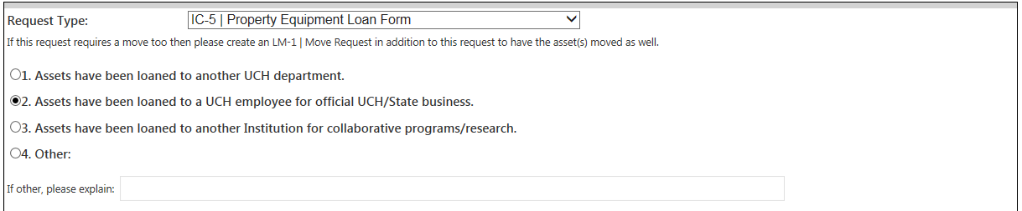

The section immediately after the form dropdown will allow you to specify the type of loan. In this case we have selected “employee” as this is the most common type of loan form. There are also selections for assets loaned to another UCH department or to an institution separate from UConn.

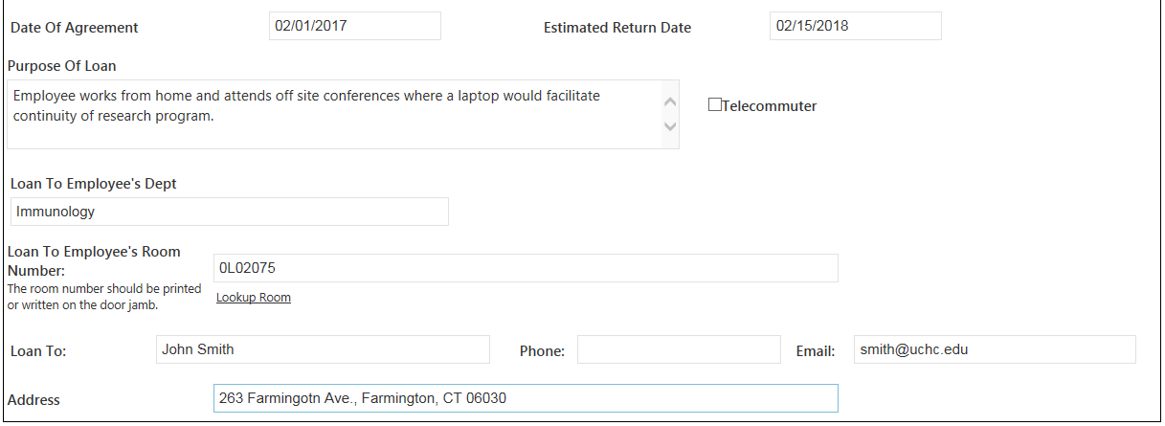

Please enter the details of the loan agreement in the next section.

- Date of Agreement:
  - This is the start date for the loan form. The annual increments for renewal will be from this date.
- Estimated Return Date:
  - This is the date the item is expected to be returned.
  - For “unending” loans, such as an employee assigned a laptop, enter the date in 1 year increments.
- Purpose of Loan:
  - Enter a detailed comment about why the equipment is being loaned.
- Loan To Employee’s Department:
  - Enter the loaning department name.
  - If this is a loan to another department or institution; enter the receiving unit’s name.
- Loan to Employee’s Room:
  - Enter the room the person is normally assigned to when on campus.
  - If this is a loan outside of UConn Health; enter the room the item would be in if not loaned out.
- Loan To:
  - Enter the receiving employee’s name and contact information.
  - If this is a loan to another institution; enter the contact information at the destination.

This concludes the parts of the form specifically addressing Loan Forms, IC-5. To complete the rest of the form go to the section on Legal Notifications (page 17).

IC-6: Property Disposition –

Transfer/Cannibalize
IC-6 Purpose: This form is to be used to record a permanent transferred to another UConn Health Department or outside institution, show loss due to cannibalization or “Other”. This could cover theft, damage, or unknown losses.
In the second section of the EFW request is a dropdown where you select the type of action you wish to perform. To keep continuity with the old processes we aligned request types with their old LM and IC form numbers. This will allow users familiar with the previous system to have a better idea of which form type to start with. The fields on the form will vary depending on which type of action is selected in the dropdown. Here we will describe the form as it appears when the IC-6 selection is made. The IC-6A and IC-6B selections will be explained in following chapters.
The Cannibalize selection should only be used by departments that are disassembling equipment and using it to augment or repair other pieces of equipment. This renders the first piece of equipment entirely unusable and there is nothing to be picked up for disposal. All parts of the equipment should have been used to salvage a second unit. THIS FORM SHOULD NOT BE USED IN PLACE OF REGULAR SURPLUS REMOVAL REQUESTS (LM-2).
If you select Cannibalize, there should be no leftover pieces. The movers will not come to pick anything up using this form. If you are taking some components but the bulk of the equipment still needs to be disposed of; please fill out the LM-2 and select “Scrap” as the condition code because you have removed components from it and it is no longer usable.
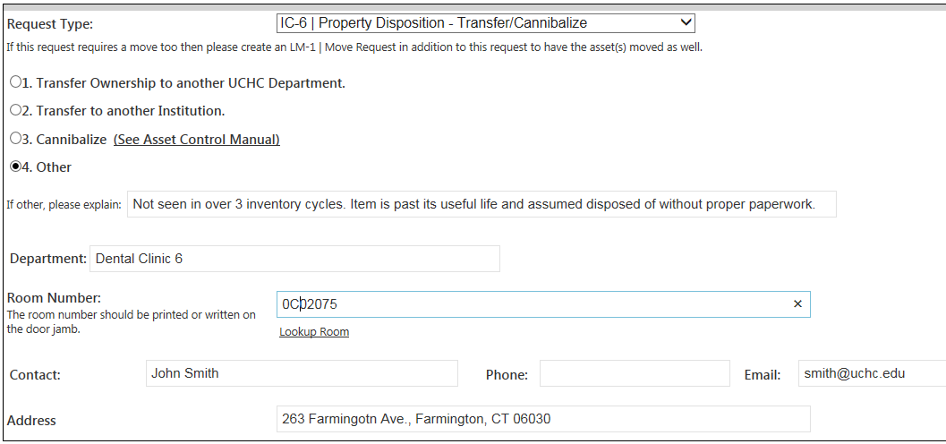
There is also an “Other” selection, which will need to be accompanied by a detailed comment explaining what happened to the equipment that requires it to be removed from the inventory listing. This could be theft, damage covered by insurance or warranty where the item is returned and replaced, or a general/unexplained loss discovered by inventory control.
This form only requires the reporting department name, room number the equipment was assigned to, and a contact point for more information regarding the loss.
This concludes the parts of the form specifically addressing Loan Forms, IC-6. To complete the rest of the form go to the section on Legal Notifications (page 17).

IC-6A: Property Disposition – Trade In
IC-6A Purpose: This form should be used when equipment is “sold” back to a vendor for a discount on a purchase order for new equipment. It requires the Purchasing Department’s input and approval.
In the second section of the EFW request is a dropdown where you select the type of action you wish to perform. To keep continuity with the old processes we aligned request types with their old LM and IC form numbers. This will allow users familiar with the previous system to have a better idea of which form type to start with. The fields on the form will vary depending on which type of action is selected in the dropdown. Here we will describe the form as it appears when the IC-6A selection is made. The IC-6 and IC-6B selections are explained in other chapters.
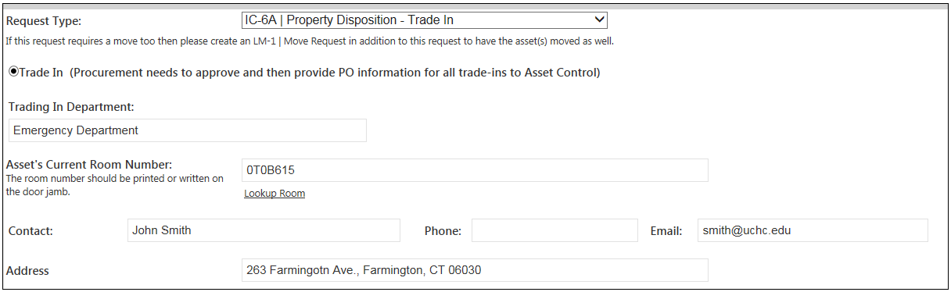
Enter the owning department and asset’s current room number. Most trade-ins will be picked up by the vendor or have other arrangements made as part of the purchase order for the new equipment. If there is nothing in the agreement about removal of the equipment you will also need to fill out an LM-1 to have the items removed by the UConn Health movers. The contact information should be the unit giving up the equipment for trade in.
This concludes the parts of the form specifically addressing Loan Forms, IC-6A. To complete the rest of the form go to the section on Legal Notifications (page 17).

IC-6B: Property Disposition – Sell
IC-6B Purpose: This form should only be used by the surplus section of OLM. This documents the sale of equipment for cash. It must be performed with oversight by the Finance Department to ensure funds are accurately accounted for.
In the second section of the EFW request is a dropdown where you select the type of action you wish to perform. To keep continuity with the old processes we aligned request types with their old LM and IC form numbers. This will allow users familiar with the previous system to have a better idea of which form type to start with. The fields on the form will vary depending on which type of action is selected in the dropdown. Here we will describe the form as it appears when the IC-6B selection is made. The IC-6 and IC-6A selections were explained in previous chapters.
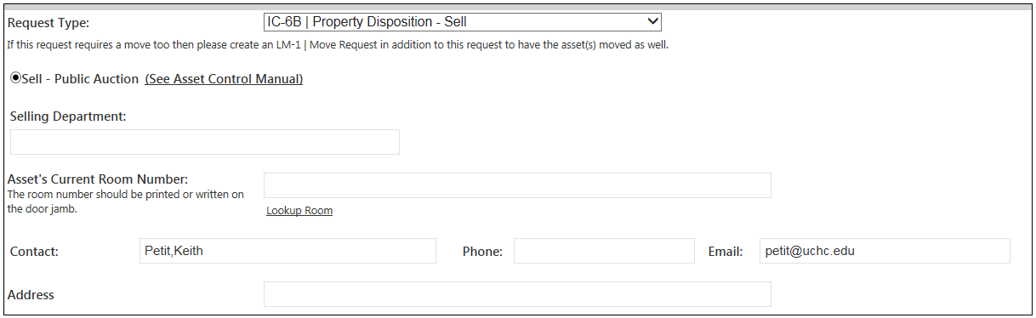
This form should only be filled out by OLM surplus staff. Sales of equipment for cash should only happen under the supervision of OLM and the Finance Department to ensure funds are properly accounted for. To send equipment for sale, please fill out an LM-2 to surplus the items.
This concludes the parts of the form specifically addressing Loan Forms, IC-6B. To complete the rest of the form go to the section on Legal Notifications (page 17).

IC-6C: Property Disposition – Cannibalize
IC-6C Purpose: This form should only be used when an item is completely destroyed to fix or augment another piece of equipment. If you are merely removing parts, such as computer memory, but there is a remaining piece of equipment then you must use an LM-2 form to send to surplus and list the condition as Scrap.
In the second section of the EFW request is a dropdown where you select the type of action you wish to perform. To keep continuity with the old processes we aligned request types with their old LM and IC form numbers. This will allow users familiar with the previous system to have a better idea of which form type to start with. The fields on the form will vary depending on which type of action is selected in the dropdown. Here we will describe the form as it appears when the IC-6C selection is made. Other IC-6 selections were explained in previous chapters.
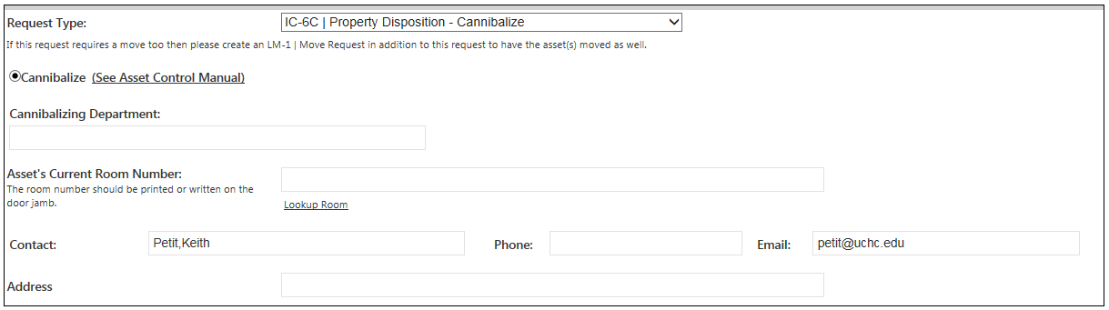
Enter the name of the department that cannibalized the equipment. OLM will need to contact that department to see if the equipment that was repaired or supplemented needs to be added to, or maintained in, the inventory file. In the current room number put the room number of the equipment which was supplemented or repaired. This will also assist us in our inspection.
This concludes the parts of the form specifically addressing Loan Forms, IC-6C. To complete the rest of the form go to the section on Legal Notifications (page 17).

Legal Notifications:

Preparing Equipment for Movement, Transfer or Disposal
The next section of the electronic form contains the legal notice regarding handling of hazardous equipment, confidential information etc. You must check off that you understand any radiological, environmental, or electronic hazards have been mitigated.

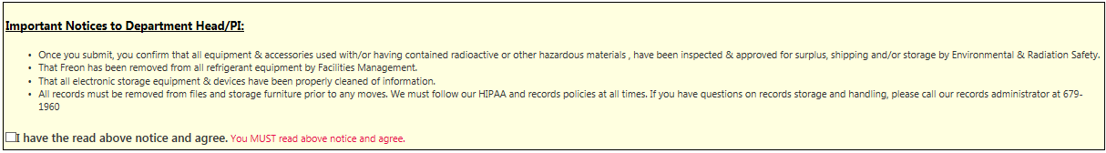

This includes removing radiological sources prior to handling by moving staff, removal of Freon or other environmental hazards prior to storage, and removal of HIPAA or confidentially sensitive data prior to computers leaving state custody (this is usually done by warehouse personnel; please contact us or the Information Technology Department if you have questions). It also covers the removal of any hard copies or paper files that may contain confidential or HIPAA data prior to leaving state custody. The box must be checked before you can proceed.

Any equipment that has chemical, biological or radiological hazards must have had a work order submitted so that Facilities Management, Environmental Safety or other responsible unit can abate the problem. Please wait to submit your form until the work order is complete. You can enter the work order number in the comments so there isn’t any confusion about what can or cannot be removed when the movers arrive.

Adding Assets to Your Form
The final section is where the items to be moved will be listed. These can be typed in from the information found on the asset or can be looked up using our search function which will be described in the next chapter.

There is currently no limit on the number of items that can be added to a single request. However, you may want to limit the number of items on a request for several reasons;
- The entire reason for electronic forms is that it eliminates the write in. Due to audit restrictions, items are not allowed to be “written in” on forms. Only basic, non-substantial, changes are allowed to be documented on a removal notice.
  - Description modifications- Chair to Chair, Swivel.
  - Serial number typographical fixes – 2zVw12 becomes 2zUw12
- Your items may have different destination or pickup locations.
  - To help our movers we ask that items bound for alternate destinations are separated so that they are able to designate what equipment should be removed from or end up in certain rooms.
- If an adjustment needs to be done to an item the entire requisition will need to be restarted for the corrections to take effect. (see audit restrictions above)
  - When a change needs to be made to a request it must be cancelled, changed, and resubmitted through the approval process.
  - All items on a resubmitted request must be left behind until the form is reapproved.
- Fewer items on a form limit the chances of there being a mistake that affects large numbers of other items.

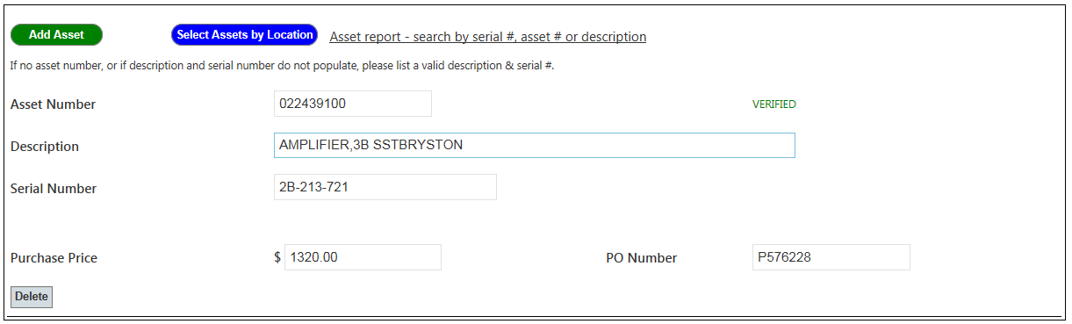

Each form starts with a single blank row at the bottom. Asset information can be entered manually or imported from the search function. To manually enter an item put the 9 digit asset tag number, found on the equipment, in the Asset Number field. If it lines up with an item in the system perfectly you will see a green “VERIFIED” on the right hand side. The Description and other system information should import automatically once you leave the field. (This may take a few seconds….be patient.) Just because an item does not come back verified does not mean it isn’t in the system. Usually it is a typo on our end and will be attended to as part of the approval process.

If you need to enter an item that does not have an asset number you can write “Not Tagged” in the asset number field. Then enter the rest of the fields manually to give as much information as possible. These items will still be processed just as they were when it was done with the paper form system. If you have any questions on items please contact OLM for clarification prior to submittal.
There are two buttons, Add Asset and Delete, which allow you to add additional lines or delete lines which were added in error. The last button shown here in blue, allows you to add an asset based on the location. This is especially helpful if you are moving an entire room.

Enter the room number using the drop down menus for building, floor and room. The assets listed to that room will be displayed. You can select the box at the right of the row, or click select all, to choose which items to add to your form. Click OK at the bottom of the screen to import them to your form. If you cannot find your asset listed to the room it is in you will need to search by number or description. This is discussed in the next chapter.

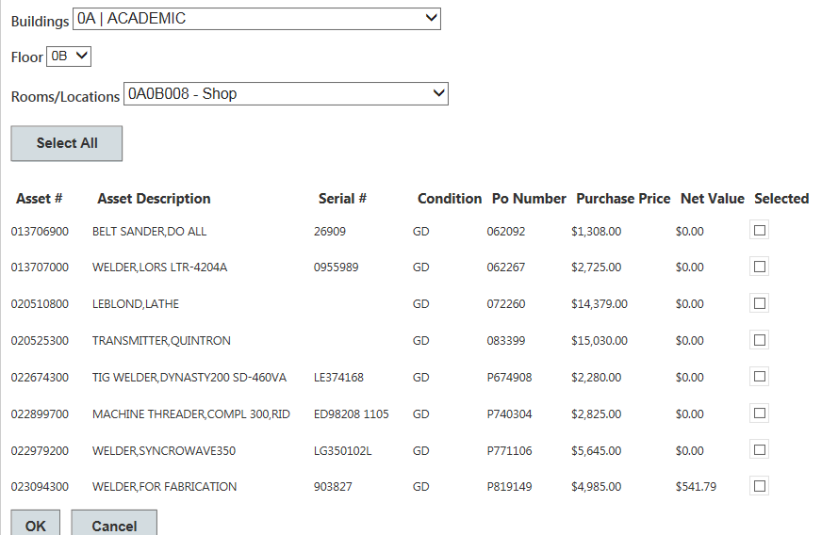

Once you have assigned all the items to your form scroll up to the submit button. This will complete your form and start it on the approval process which is discussed in a later chapter.

Looking Up Current Asset Information
If you are unable to find your item by using the “Select Assets by Location” tool then you may need to use the link to the right of that button. This will allow you to search by asset number, serial number or description.

Clicking the link will bring you to a custom dashboard where you can search using multiple criteria. Each one can be used to narrow the results set. But if you are looking for something where you have a full asset number you may want to leave the rest of the criteria as wide as possible.

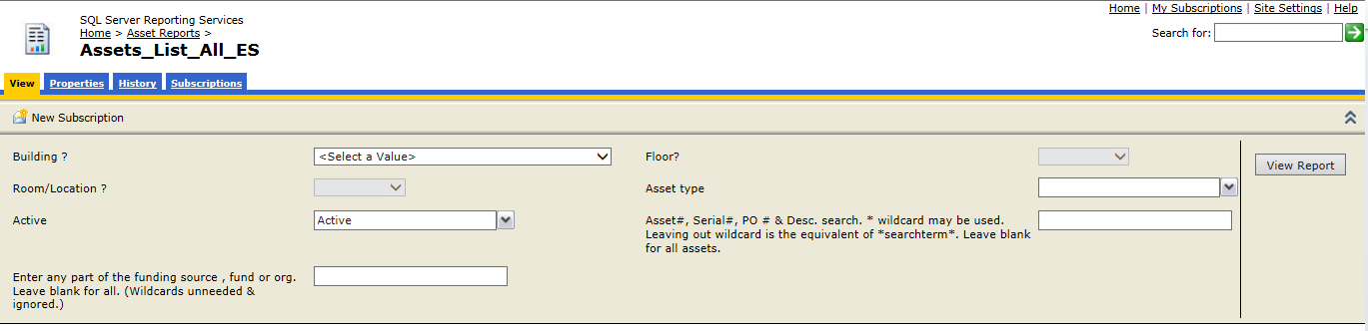
- Building:
  - Enter a building number or use ~All
- Floor:
  - Enter a floor or use ~All
- Room:
  - Enter a room number or use ~All
- Asset type:
  - Capital, Controllable or All
- Active:
  - This report can show both Active and/or Obsolete assets. Generally it should be Active.
- Asset/Serial/Description/PO
  - This is a wildcard field that will search the entire database looking for an asset number or keywords.
- Funding Source:
  - You can also narrow your search by entering a funding code to see the items listed with that code as the purchasing fund.
  - Some assets do not have purchasing information assigned to them. This field may return inaccurate or incomplete results.
Once you have entered all the appropriate criteria click the “View Report” button on the right side. Your report will display below the header section. You can select a format from the dropdown and click the Export link to download and save a copy of the report.
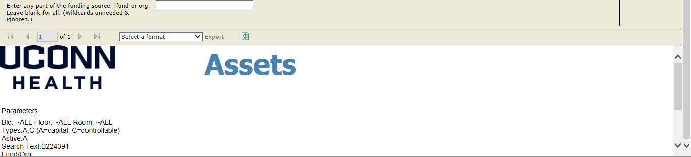
Any problems with information contained in the report should be addressed to OLM at assets@uchc.edu so that the inventory file is kept as clean as possible. If equipment simply needs a room change then it can be done by filing an LM-1 and selecting option 1.

Workflow: Request Routing and

Searching for Requests
Once you have hit submit your request will begin moving through the workflow process. It will be automatically routed to the next person through the use of email notifications. You will be able to monitor the progression of your requests and search for requests using the toolbar at the very top of the form website.
The lists shown above may differ from those shown on your form due to permissions. But all users should have access to:
- Create Request
  - Allows the entering/origination of requests.
- My Requests
  - Allows a user to view past requests created by their profile.
- All Requests
  - Allows users to see requests submitted by other users, so that they can monitor items submitted for their unit. Users can only modify requests created or approved by them.
The All Requests list allows users to filter so they can see just the forms which may apply to their unit. You can enter the Fund or Org used on the form as well as select the status from the drop down in the top left corner. The options are All Open, Completed or Canceled.
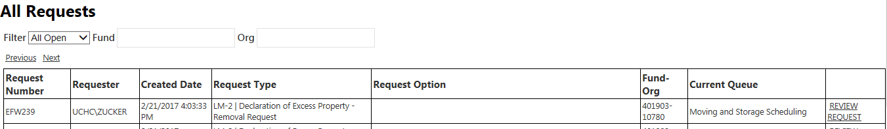
Approvers will also have access to Requests Pending My Approval. This allows them to see items in their queue which still require action. Most queues have multiple approvers assigned, but some specialized ones may only have a single user. This can cause delays if the person is on vacation or out sick. Contact OLM to discuss options for rerouting the form to another authorized user.
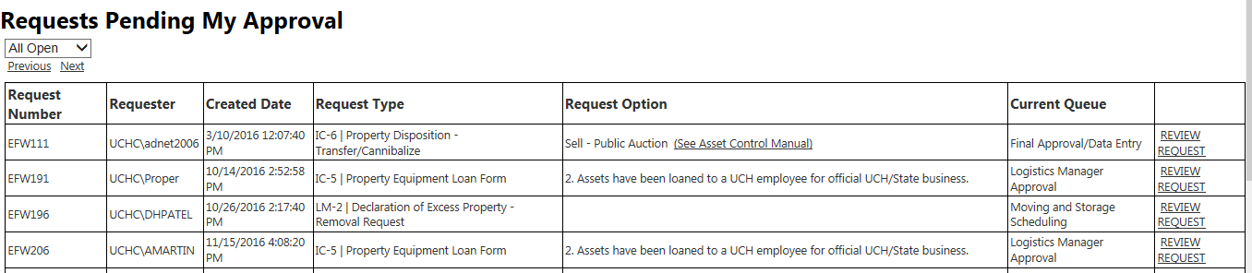
Most users’ lists will only consist of items in a single “Current Queue” because they will only be assigned to a single approval list. The example shown above is for an approver who manages forms on multiple steps. To review a request, simply click on the link in the far right column. The drop down list in the top left allows you to view All Open, Canceled or Completed requests. For most purposes this should be set to All Open.
If you believe a form is “stuck” and you would like to know who to contact you can see what queue it is in and then who belongs to that queue. Find your request using the search methods detailed above. Then click the link to review the request.
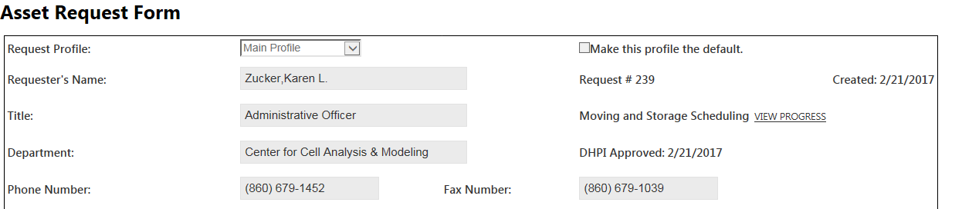
Towards the top of the form on the right you will see the link to View Progress. Immediately to the left of the link is the name of the current queue. Clicking on the link will bring you to the workflow stages screen. This allows you to see how many current steps there are in the workflow and allows you to see how many people are available to approve the form in its current queue.
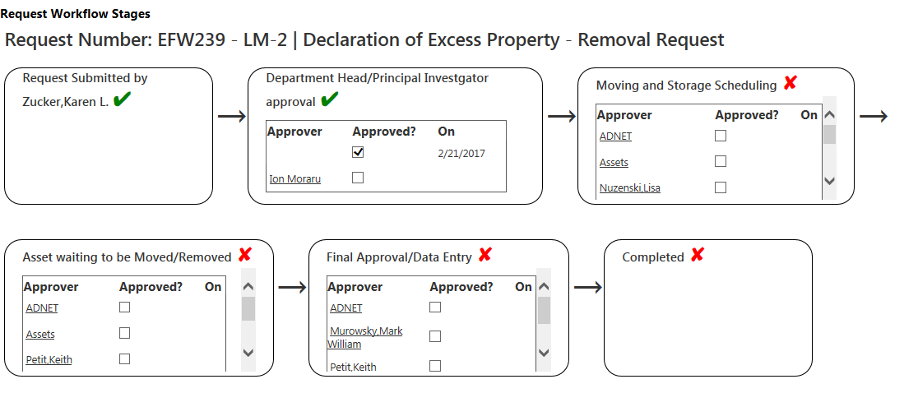
Any questions pertaining to material found in any section of this manual can be addressed to the Office of Logistics Management via email to assets@uchc.edu.

Refer to: http://opa.uchc.edu/opa_inv/pam_home.html
Refer to: http://www.osc.ct.gov/manuals/PropertyCntl/index.html
Capital – Items valued above $5000.00 and having a useful life greater than 1 year.
Controllable – Items having a useful life greater than 1 year and which have been determined by management to require annual inventory due to an elevated risk of loss, usually from theft.
Tangible – Having physical substance, able to be manipulated in space.
Intangible – Having no physical substance but still having value, ex. Intellectual Property, Copyrights, Software or legal rights to future tangible or intangible assets.
Consumable – Items meant for single or limited use which are usually disposable in nature, ex. Gloves, Medication, Paper Products or Fluids.

